**Contenedor sin bordes (Versiones viejas)**

.qs-container .qsc-item-wrapper,.qs-container .qsc-tab-row{

border:none;

}

**Línea en Simple KPI**

& .qv-object-qsstatistic {

border-right: solid 4px ;

border-color: #b67016;

width: auto;

}

**Componentes del Simple KPI**

& .statistic-1 .value *{}

& .statistic-1 .label *{}

**Ejemplos**

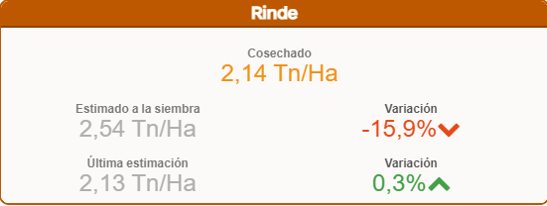

Items per row: 2

1 Medida oculta (2°)

& .statistic-1 .value{

width: 200%

}

& .statistic-1 .label{

width: 200%

}

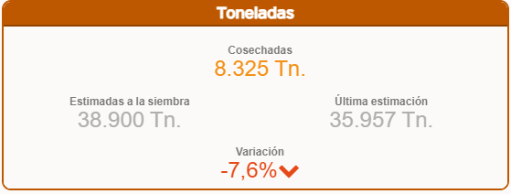

Items per row: 2

1 Medida oculta (2°)

& .statistic-1 .value{

width: 200%

}

& .statistic-1 .label{

width: 200%

}

& .statistic-5 .value{

width: 200%

}

& .statistic-5 .label{

width: 200%

}



& .qv-object-qsstatistic {

border-color: #485870;

border-radius: 9px 9px 0 0;

}

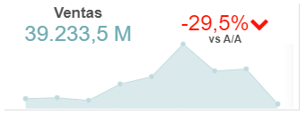

& .statistic-1 .label{

font-size: 120%;

}

& .statistic-1 {

width: 40%;

margin-left: auto;

margin-right: auto;

margin-top: 0px;

}

& .statistic-2 {

width: 40%;

margin-left: auto;

margin-right: auto;

margin-top: 10px;

}

& .statistic-3 {

width: 100%;

height:30% !important;

margin-left: auto;

margin-right: auto;

margin-top: -35px;

}

& .statistic-3 .value .qv-object-wrapper.ng-scope.ng-isolate-scope .qv-object-linechart{

height: 72%;

margin-top: 30px;

}



**Selector centrado**

.qv-object-qlik-variable-input div.qlik{

position: relative;

height: 100%;

}

.qv-object-qlik-variable-input div.qlik .qui-input.lui-input{

height: 100%;

}



& .statistic-1 .label *{

font-size: 18px;

writing-mode: vertical-lr;

text-orientation: mixed;

}

& .qv-object-qsstatistic {

border-radius: 0 10px 10px 0;

background: linear-gradient(180deg , #dea95b 10%, #c7c76d 100%);

}



& .qv-object-qsstatistic {

border: solid 1px ;

border-color: #3DA69D;

width: auto;

height: 98%;

display: flex;

}

& .statistic-1 .value *{

font-size: 80%;

}

& .statistic-5 .value *{

font-size: 80%;

}

& .statistic-9 .value *{

font-size: 80%;

}

.qv-object-qsstatistic .ui.four.statistics .statistic {

display: flex;

justify-content: center !important;

}/*

& .statistic-1 {justify-content: flex-start !important;}

/*

& .statistic{

border-right: solid 1px;

border-color: #f0910f;

box-sizing: border-box;

}

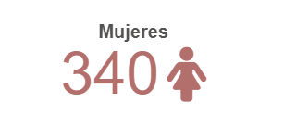

@import url('https://cdnjs.cloudflare.com/ajax/libs/font-awesome/5.15.1/css/all.css');

& .statistic-1 .value .fa-female{

font-style: normal;

font-size: 60px;

margin-left: 8px;

}



Responsive: off

Items per row: not set

& .statistic{

float:left;

box-sizing: border-box;

clear:both;

}

& .statistic-1{

width: 65%;

margin-left: auto;

margin-right: auto;

}

& .statistic-1 .value{

font-size: 300%;

}

& .statistic-1 *{

margin-left: auto;

margin-right: auto;

}

& .statistic-2 {

width: 35%;

margin-bottom: 0px;

margin-left: auto;

margin-right: 0px;

margin-top: -5px;

}

& .statistic-3 {

width: 35%;

margin-left: auto;

margin-right: 0px;

margin-top: -20px;

}

& .statistic-2 .value {

font-size: 128%;

margin-left: auto;

margin-right: 0px;

margin-bottom: 0px;

}

& .statistic-3 .value {

font-size: 128%;

margin-left: auto;

margin-right: 0px;

}

& .statistic-3 .label{

font-size: 78%;

}

& .statistic-2 .label{

font-size: 78%;

margin-right: 16px;

}



@import url('https://cdnjs.cloudflare.com/ajax/libs/font-awesome/5.15.1/css/all.css');

& .statistic-1 .value .fa-file{

font-style: normal;

font-size: smaller;

margin-left: 8px;

}

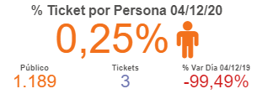

@import url('https://cdnjs.cloudflare.com/ajax/libs/font-awesome/5.15.1/css/all.css');

& .statistic-1 .value .fa-male{

font-style: normal;

font-size: 45px;

margin-left: 8px;

}

.qs-container .qsc-item-wrapper,.qs-container .qsc-tab-row{

border:none;

margin: -5 !important;

padding:-5 !important;

}

.qs-container .qsc-item-wrapper,.qs-container .qsc-tab-row{

border:none;

margin: -5 !important;

padding:-5 !important;

}

.qv-object-qsstatistic .ui.statistics>.statistic {

display: -ms-inline-flexbox;

display: inline-flex;

-ms-flex: 0 1 auto;

flex: 0 1 auto;

-ms-flex-direction: column;

flex-direction: column;

margin: 0em;

max-width: auto;

}

div.statistic.statistic-3{

cursor: pointer;

width: 33% !important;

flex-direction: row;

}

div.statistic.statistic-4{

cursor: pointer;

width: 33%!important;

flex-direction: row;

}

div.statistic.statistic-2{

cursor: pointer;

width: 33% !important;

flex-direction: row;

}

div.statistic.statistic-1{

cursor: pointer;

width: 100%;

}

& .statistic-2 .value{

font-size: 150%;

}

& .statistic-2 .label{

font-size: 67%;

}

& .statistic-3 .value{

font-size: 150%;

}

& .statistic-3 .label{

font-size: 67%;

}

& .statistic-1 .value{

margin-bottom:5px;

}

.qv-object-qsstatistic .ui.statistics {

margin:0;

}

& .statistic-4 .value{

font-size: 150%;

}

& .statistic-4 .label{

font-size: 67%;

}